Measuring and Comparing Inequality overtime within a country and between countries

Income inequality refers to the uneven distribution of income within a population (Kopp, 2024). This issue is critical because when income is distributed unequally, it can lead to various social and economic challenges, affecting not only individuals but also the stability and well-being of society, therefore, understanding income inequality is essential. This essay aims to explore income inequality trends by comparing Namibia and Denmark’s inequality trends between 1980 and 2010 using Lorenz curves. Part A will examine inequality trends over time in Namibia, Part B will compare inequality between Namibia and Denmark, and Part C will focus on the performance of the South African education system compared to Denmark and discusses the impact of various policies aimed at reducing inequality in education.

Part A

Lorenz curves on Namibia from 1980 to 2010

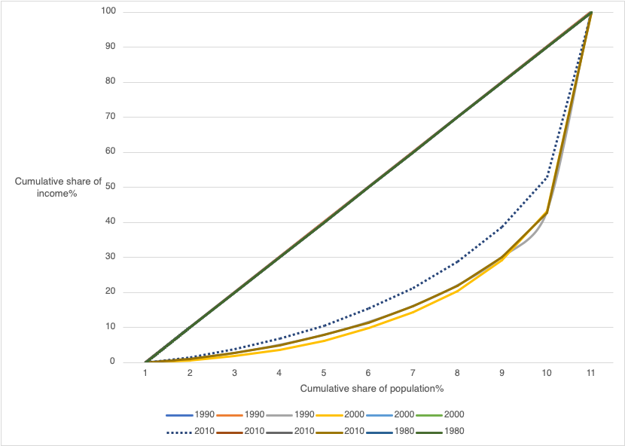

The income inequality of Namibia is deeply tied to its apartheid past. According to the World Bank in Namibia, “A pre-1990 history of the systematic exclusion of the black majority from full participation in economic activities continues to shape society and the economy, constraining the country’s economic and social progress to this day” (April,2024). Most of Namibia’s resources and wealth were owned by the white minority, restricting majority of the population(blacks) from access to education and jobs as according to Araar(2009), the poor are mainly the less educated with 80% of the poor having attained either primary education or have never attended formal education. This results in a high unemployment rate, increasing income inequality.

In addition, according to the Lorenz curves, there has been a decrease in the income inequality in Namibia from 1980 to 2010.This is shown by a decrease in the area under the graph over the years. According to Aiken (2018) ‘Economic disparity has improved in recent years but remains extremely high. Namibia's mining and agriculture sectors are part of the reasons that have led to a decrease in income inequality over the years.

On the other hand, the Lorenz curves show that there was a slight increase in income inequality between 1980 and 1990.The income inequality between these years was quite high, which was due to Namibia’s apartheid past and colonia history. However, there was an increase in income inequality from the years 1990 to 2000. as the cumulative share of income decreased amongst the population. From 2000 to 2010 there was a decrease in income inequality due to an increase in the economic growth of Namibia.

Part B

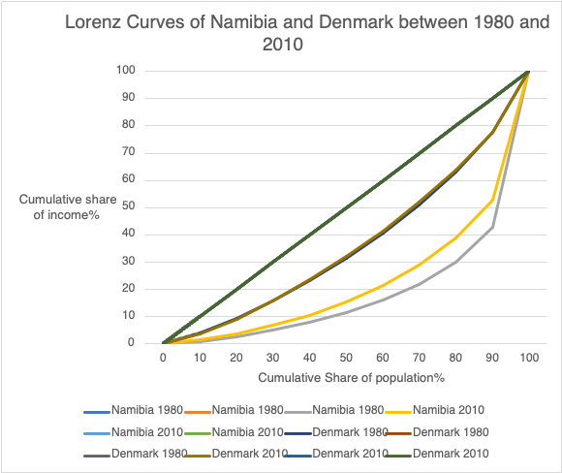

In 1980 Denmark had a lower rate of inequality (blue curve) in comparison to Namibia (grey curve). This is evident as Denmark’s Lorenz curve is closer to the perfect inequality curve than Namibia’s Lorenz curve that is further away from the perfect equality line signifying a higher income inequality.

In 2010 Denmark’s income inequality (brown curve) was also lower than that of Namibia (orange curve) as shown by the Lorenz curves.

‘Denmark has been noted as having one of the lowest income inequality ratings in the world and has been known to maintain relative stability in this metric throughout decades past’(David and Jonas,2000) , this is supported by the Lorenz curves as the area under the graph from the perfect inequality line to Denmark is not as huge in comparison to Namibia. In addition, as there was a slight decrease in the income inequality in Denmark between 1980(blue curve) to 2010(orange curve).The reason for such low level of inequality can be partly explained by the breadth of the redistributive system in Denmark, as the strong welfare system plays a crucial role in mitigating the impact of market income inequality on disposable income inequality( Causa et al,2018)

On the other hand, there was a decrease in inequality in Namibia between 1980 and 2010, as after Namibia gained its independence, the country’s income inequality started decreasing as more people had access to things like education and jobs. This decreased the income inequality between 1980 and 2010 in Namibia. According to the Borgen Project (2023), Namibia has the second most unequal wealth distribution globally, with a Gini coefficient of 0.63, after South Africa, making it one of the most unequal countries, this is evident on the graph as the Lorenz curves are far from the perfect equality line.

In a nutshell, it is evident that the income inequalities between both Namibia and Denmark are quite different as Namibia has a higher rate of income inequality, caused by its apartheid and colonial history and Denmark tends to have lower trends of income inequality due to its redistributive system and strong welfare system.

Part C

Educational attainment is often cited as a significant driver of income inequality. Since the end of apartheid, South Africa has made progress in expanding access to education. However, the quality and outcomes of education remain uneven across racial and socio-economic lines. For example, research indicates that whites earn 40% more per additional year of education compared to Africans and 20% more compared to coloreds (Salisbury, 2015). This disparity is mainly rooted in South Africa’s apartheid and colonial history, which created an unequal distribution of educational resources among different racial groups. The white population had greater access to quality education than the black and colored populations. As a result, the uneven distribution of educational opportunities has contributed to persistent income inequality in South Africa.

As a result of South Africa's apartheid history, primary and secondary schools were largely the preserve of white children, with a much smaller number of schools for 'colored', 'Indian' and 'African' children (Brodowicz,2024). While there have been improvements in educational access since 1994, achievement within the education sector is not equally distributed.

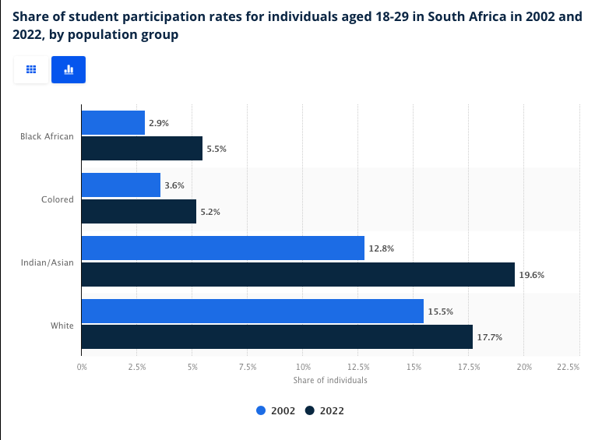Statista Research Department (2023)

According to Statista Research Department (2023), as of 2022, 5.5 percent of Black Africans aged 18 to 29 were enrolled at a higher education institution in South Africa, which marks an increase of 2.6 percentage points compared to 2002. And while Black Africans constituted most young adult students in numbers, the participation rate of this population group continued to be lower compared to the Indian/Asians at 19.6 percent and the white population group at 17.7 percent.

From the provided statistics, it is evident that the white population had more access to education between 2002 and 2022 in comparison to the Black and Colored populations. The participation rate of Black and Colored students continued to be lower than that of the white population between 2002 and 2022.

However, some policies have been implemented to reduce inequality in education. Policies like the no-fee policy have been implemented to try and reduce inequality in South Africa as according to Hall and Monson (2006), ‘The No-fee Schools policy abolishes school fees in the poorest 40% of schools nationally for learners from Grade R to Grade 9’. This then ensures that children from low-income households can access basic education without financial barriers.

In addition, scholarship and bursary programs are other policies implemented to reduce inequality. This policy aims to give financial support to students that come from disadvantaged backgrounds. Bursaries allow students from low-income households to be able to access higher education thereby reducing inequality.

Although interventions such as the no-fee policy and bursary programs have contributed to increasing educational access for disadvantaged students, the effectiveness of these measures in fully reducing inequality remains limited. The policies have made some progress by removing financial barriers and providing support to underprivileged students. However, inequality in access to education is still significantly high, with many students still lacking access to quality education. This indicates that, despite the positive impact of these reforms, significant challenges remain.

In conclusion, having looked at the income inequality trends between Namibia and Denmark from 1980 to 2010 using Lorenz curves, and examining the performance of the South African education system, it is evident that Namibia exhibits higher levels of inequality than Denmark. In addition, while various policies have been implemented in South Africa to enhance access to education, the effectiveness of these policies remains limited, as significant challenges persist.

Reference

Author links open overlay panelTaylor Salisbury *et al.* (2015) *Education and inequality in South Africa: Returns to schooling in the post-apartheid era*, *International Journal of Educational Development*. Available: <https://www.sciencedirect.com/science/article/abs/pii/S0738059315000802> [20 September 2024].

Cowling, N. (2023) *South Africa: Student participation rates by Population Group*, *Statista*. Available: <https://www.statista.com/statistics/1115545/student-participation-rates-in-south-africa-by-population-group/> [20 September 2024].

Developer (2021) *Inequality in Namibia: Decreasing but still significant, O’Neill.* Available:

https://oneill.law.georgetown.edu/inequality-in-namibia-decreasing-but-still-significant/ [ 20 September 2024].

Kopp, C.M. (2024) *Income inequality definition: Examples and how it’s measured, Investopedia.* Available:

https://www.investopedia.com/terms/i/income-inequality.asp [20 September 2024].

Project, B. (2024) *Inequality and poverty in Namibia: A gaping wealth gap*, *The Borgen Project*. Available: <https://borgenproject.org/inequality-and-poverty-in-namibia/> [ 20 September 2024].

Site homepage (2016) *OECD iLibrary.* Available:

https://www.oecd-ilibrary.org/ [20 September 2024].

(No date a) *UCT*. Available: <https://uct.ac.za/sites/default/files/media/documents/UCT_Handbook_3_2022.pdf> [ 20 September 2024].